**Buffering**

Buffer = physical memory for storing data (temporarily)

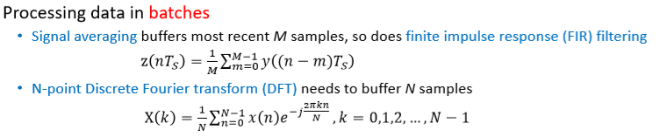FIR = Finite impulse response

DFT = Discrete Fourier transform

design consideration:

* Data type
* Buffer Size
* Write data samples to the buffer
* Read data samples from the buffer
* Memory (Dynamic vs static) allocation

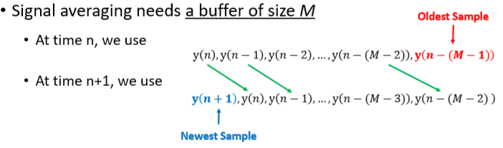**Circular buffer**

Using a signal averaging buffer ->

We can use a shift register.

Interrupts with this buffer can cause some data samples to get lost

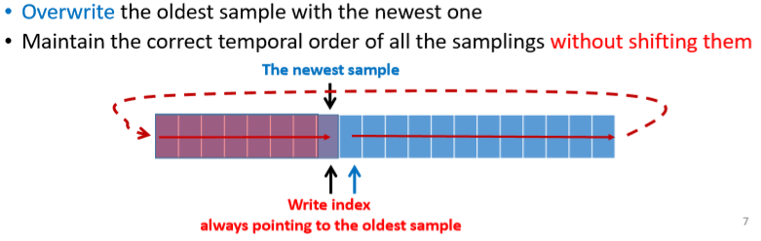**Double buffer** (use this for data protection)

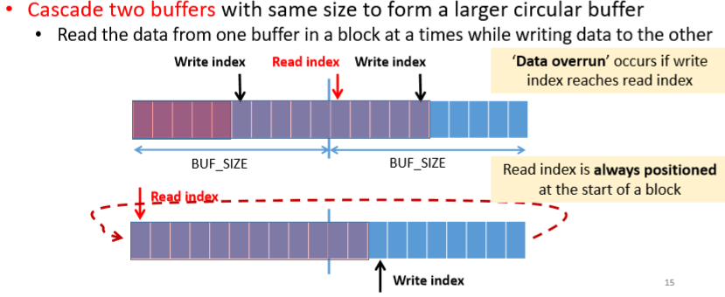Provide protection to buffered contents under interrupt conditions.

Could implement a Triple buffer

* If more protection is needed under interrupt conditions.
* Better protection -> longer delays